Polygon–Organic Closed Shapes
# Source: AI Source: Provided by: [Data Path: Persons Table -> ID Column: 1, Name_En Column: Motasem Essam] -> From: [ChatGPT] on [7/25/2026]
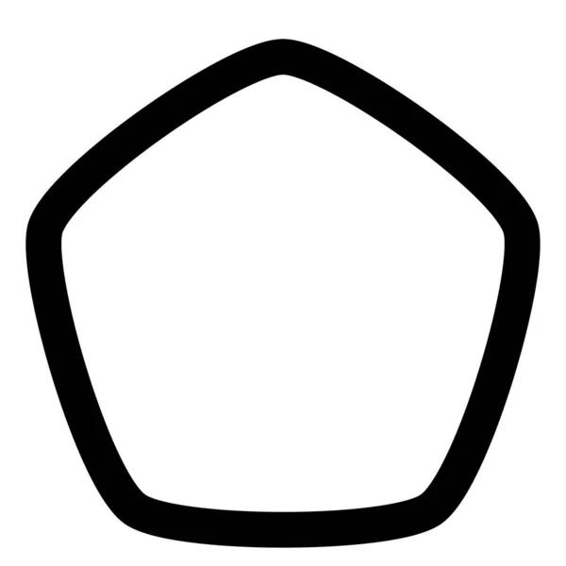
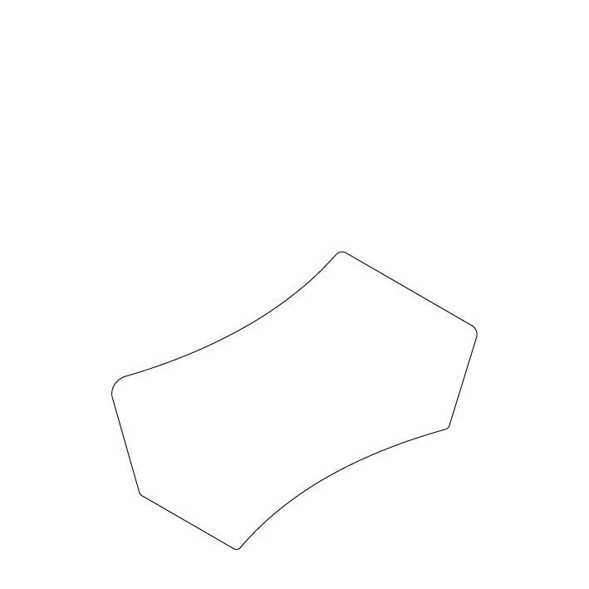
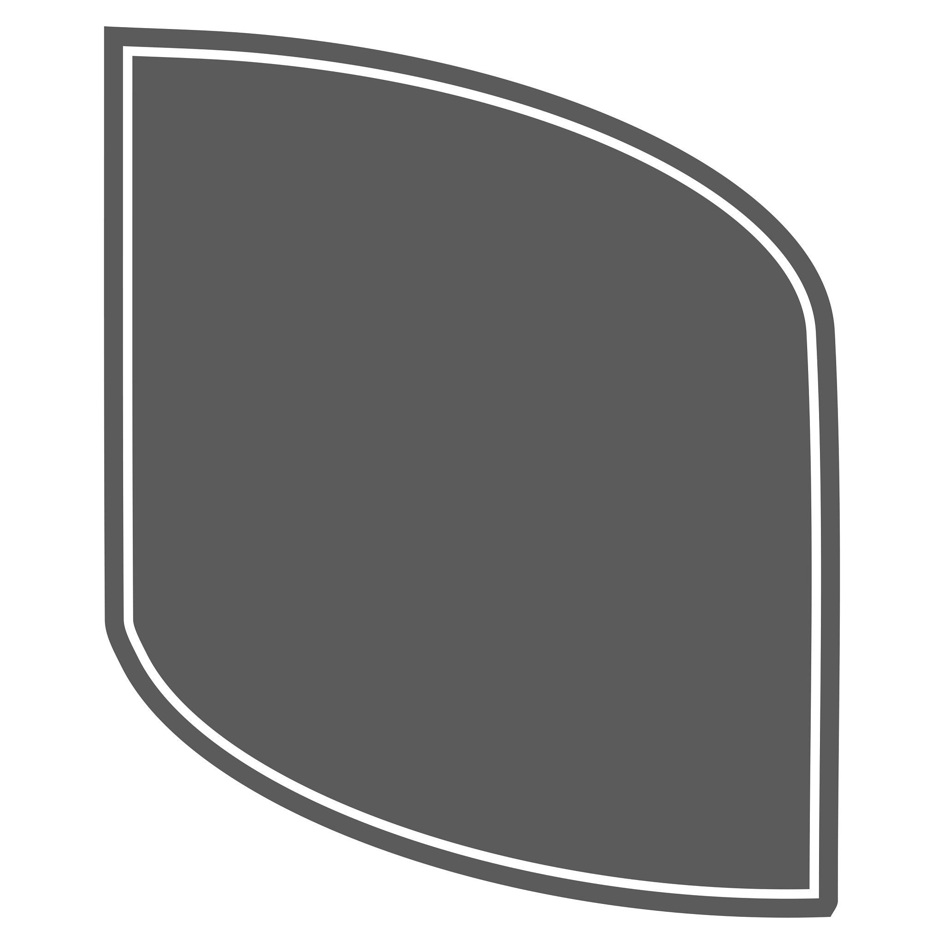
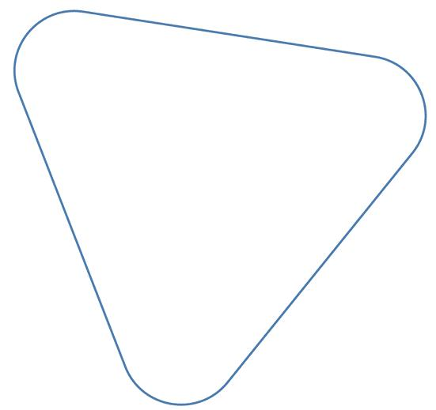
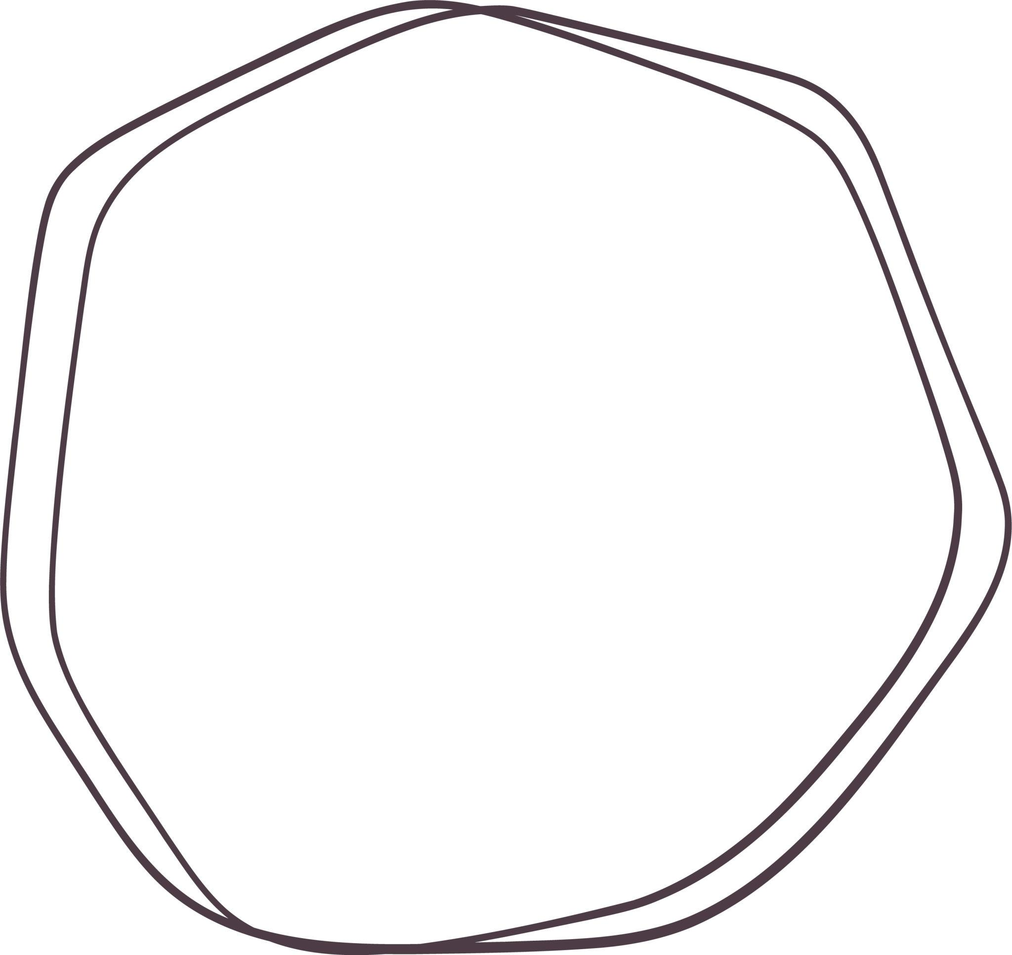

Definition
# Source: AI Source: Provided by: [Data Path: Persons Table -> ID Column: 1, Name_En Column: Motasem Essam] -> From: [ChatGPT] on [7/25/2026]
A Polygon–Organic Closed Shape is a closed mixed shape whose boundary combines straight polygonal segments with smooth, irregular, organic-looking curved portions.
$$\boxed{\text{Polygon–Organic Closed Shape}=\text{Polygonal Segments}+\text{Organic Curves}+\text{Closed Boundary}}$$
It is classified as a mixed shape because its boundary contains both straight-line and non-standard curved components.

Types of Polygon–Organic Closed Shapes

1. Triangle–Organic Closed Shape
# Source: AI Source: Provided by: [Data Path: Persons Table -> ID Column: 1, Name_En Column: Motasem Essam] -> From: [ChatGPT] on [7/25/2026]
A closed shape combining triangular straight sides with an organic curved portion.
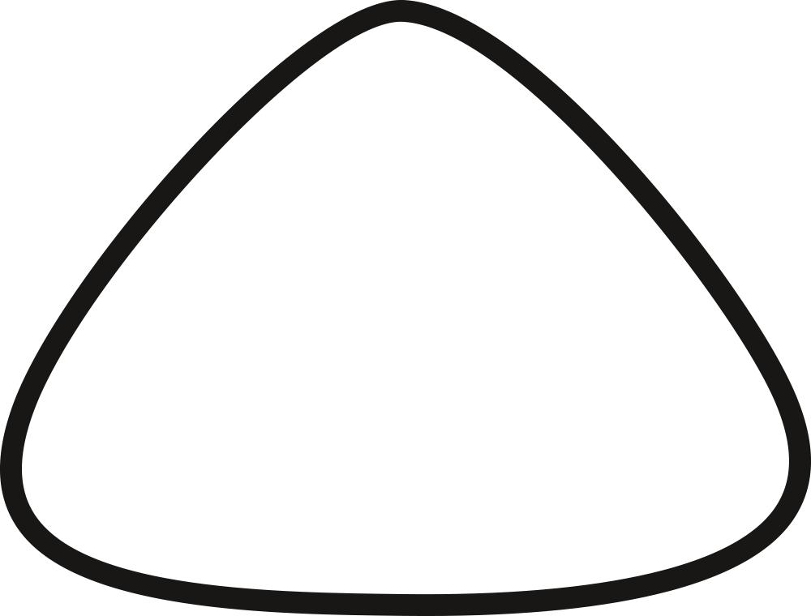
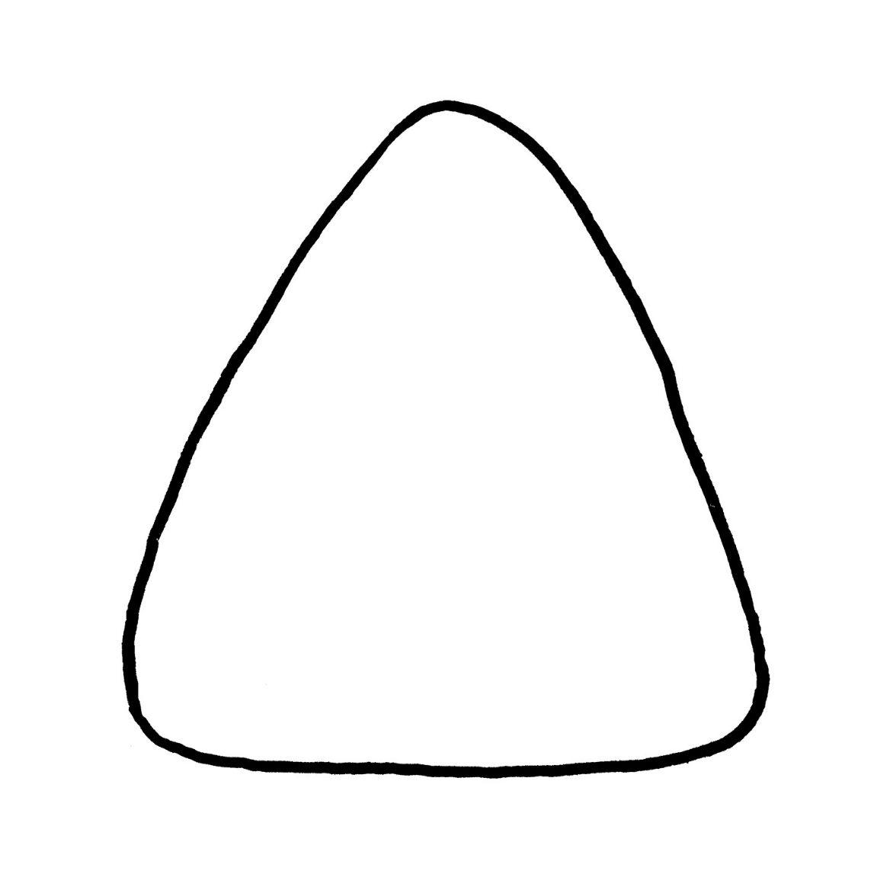
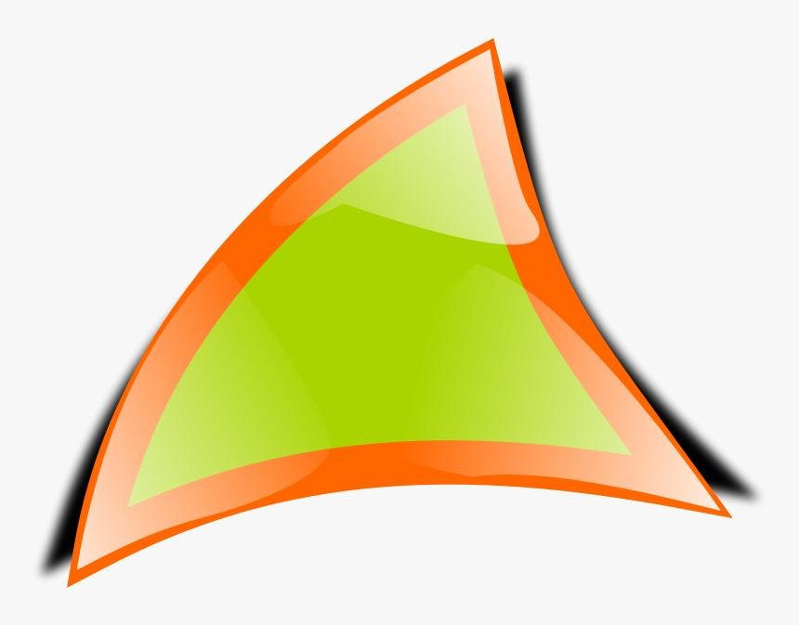
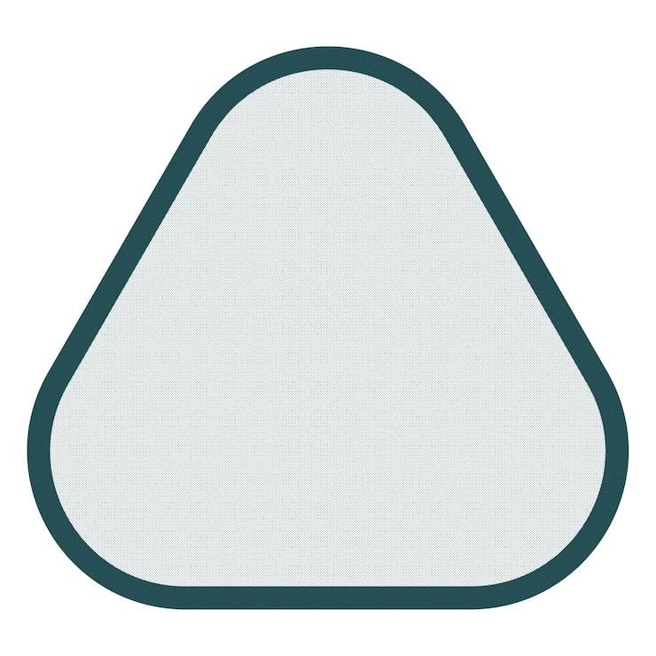
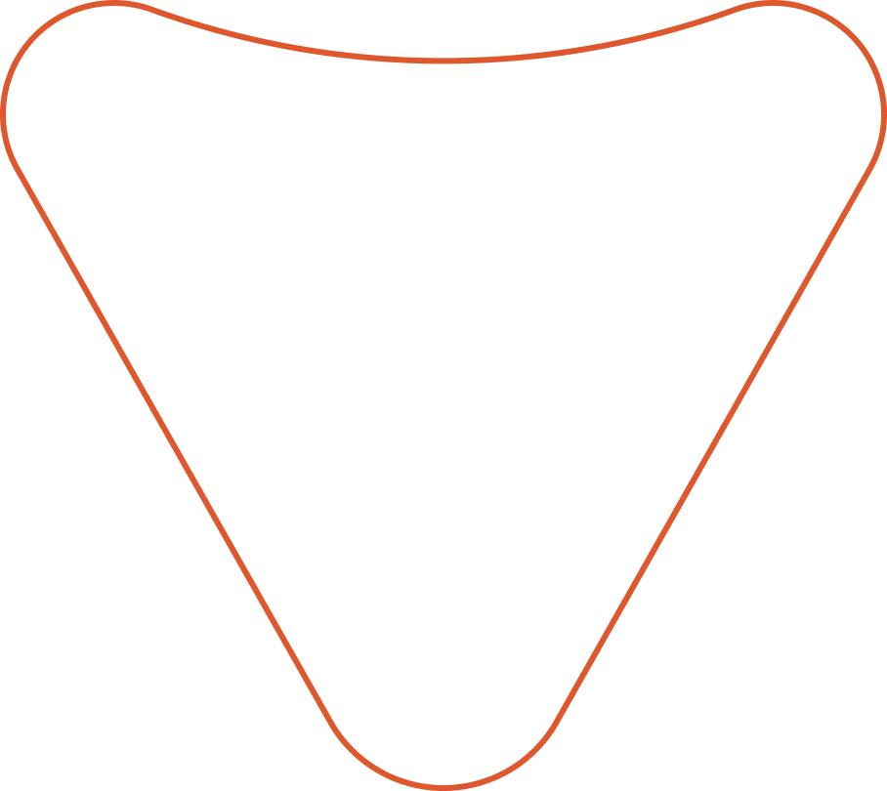
The boundary contains:
$$\boxed{\text{Triangle Segments}+\text{Organic Curve}}$$

2. Quadrilateral–Organic Closed Shape
# Source: AI Source: Provided by: [Data Path: Persons Table -> ID Column: 1, Name_En Column: Motasem Essam] -> From: [ChatGPT] on [7/25/2026]
A four-sided polygonal component combined with an irregular organic curve.
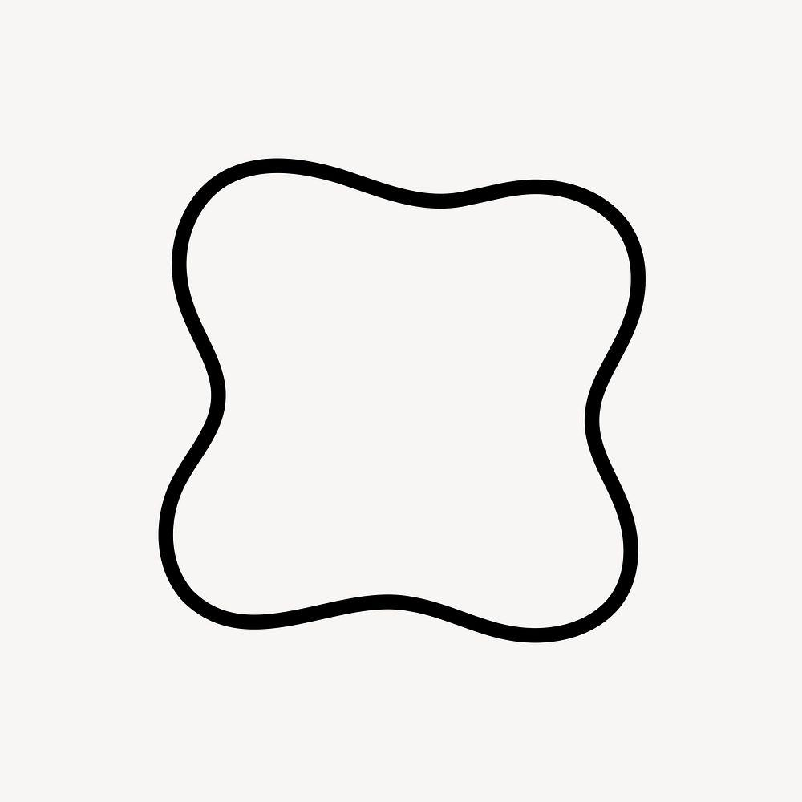
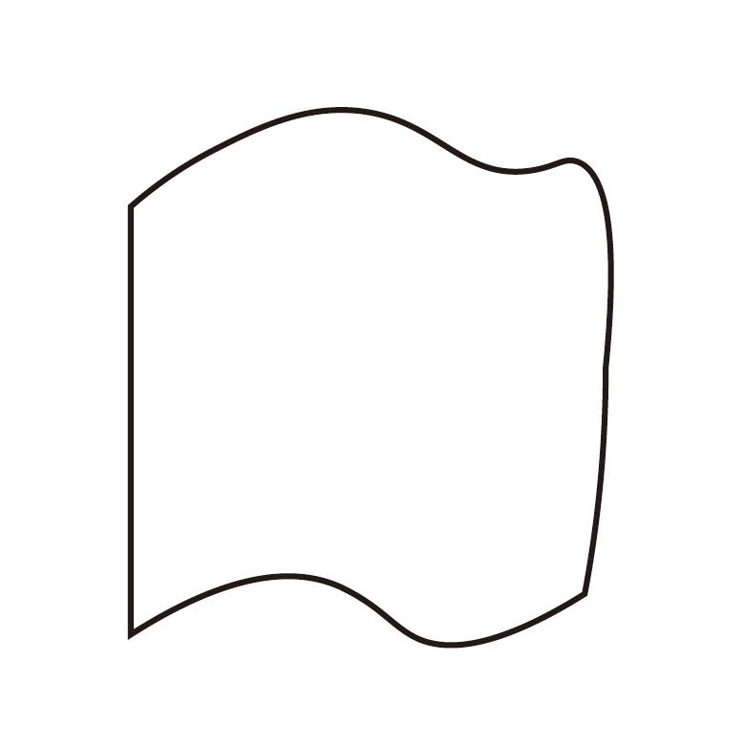
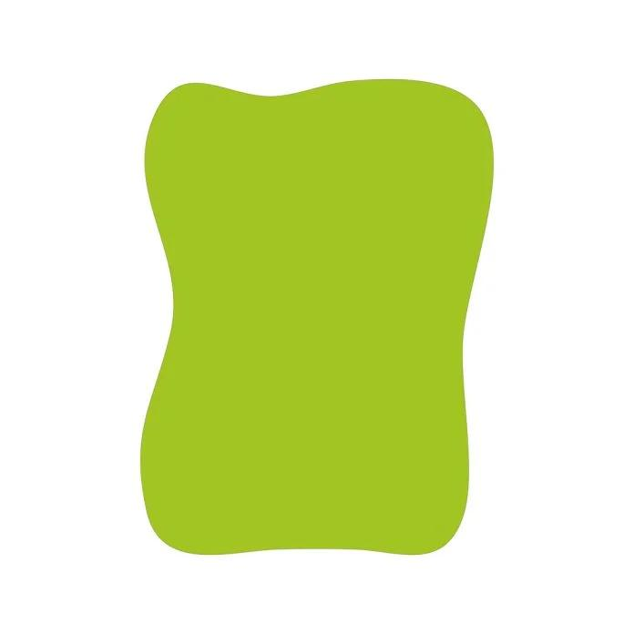
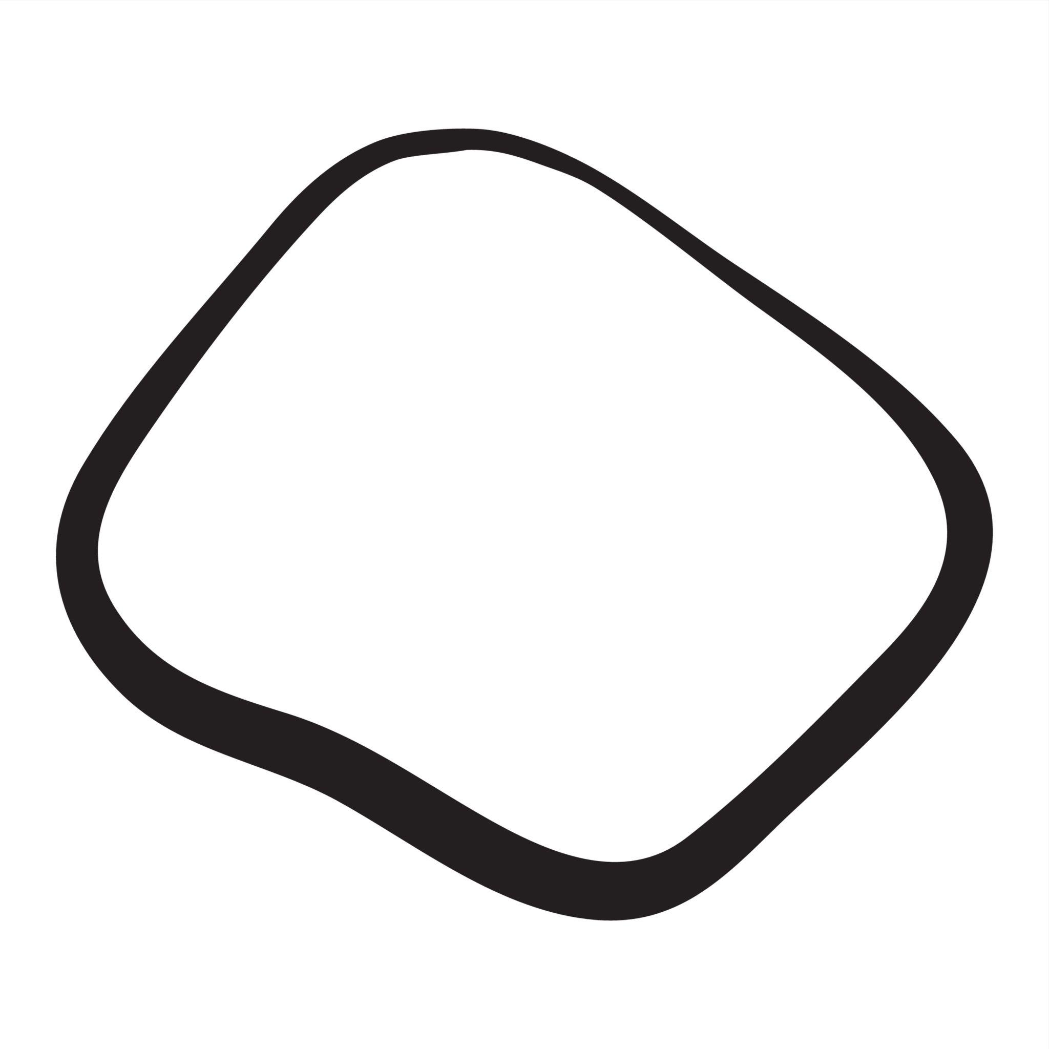
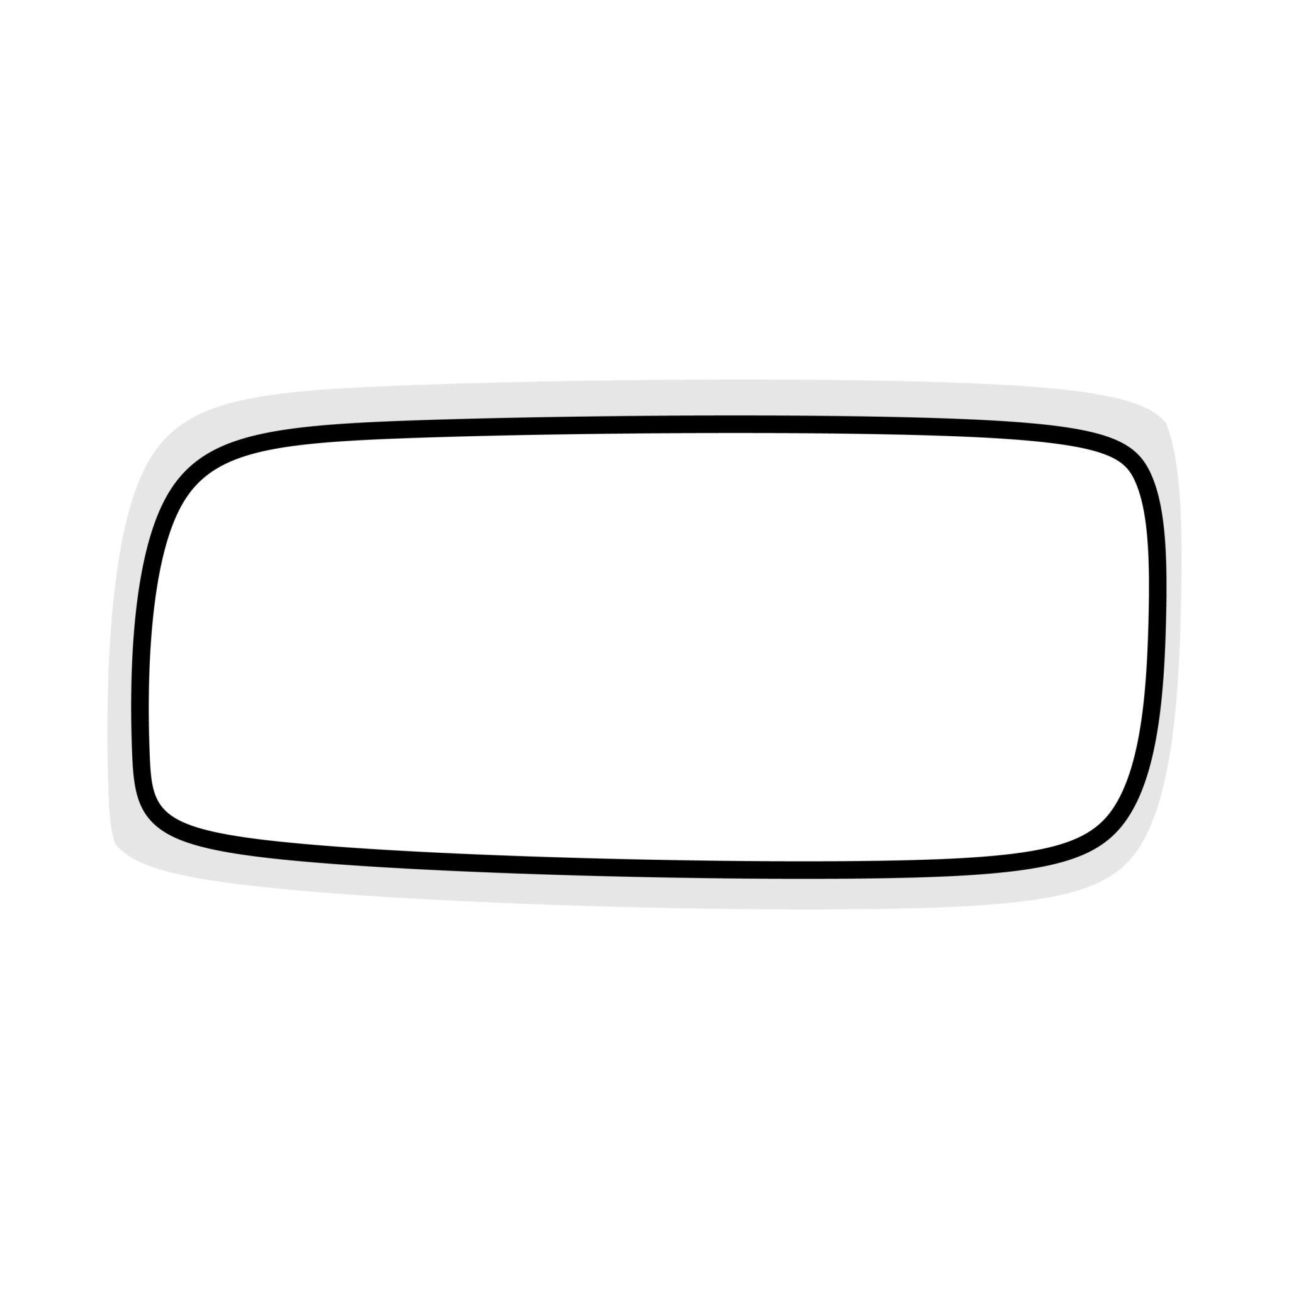
A rectangle or other quadrilateral can form part of the boundary while an organic curve forms the remainder.

3. Pentagon–Organic Closed Shape
# Source: AI Source: Provided by: [Data Path: Persons Table -> ID Column: 1, Name_En Column: Motasem Essam] -> From: [ChatGPT] on [7/25/2026]
A five-sided polygonal portion combined with one or more irregular curved portions.
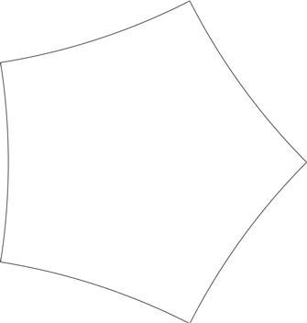

4. Hexagon–Organic Closed Shape
# Source: AI Source: Provided by: [Data Path: Persons Table -> ID Column: 1, Name_En Column: Motasem Essam] -> From: [ChatGPT] on [7/25/2026]
A six-sided polygonal component combined with organic curved boundaries.
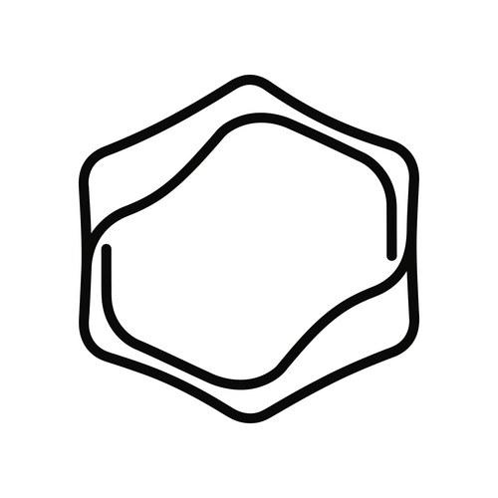
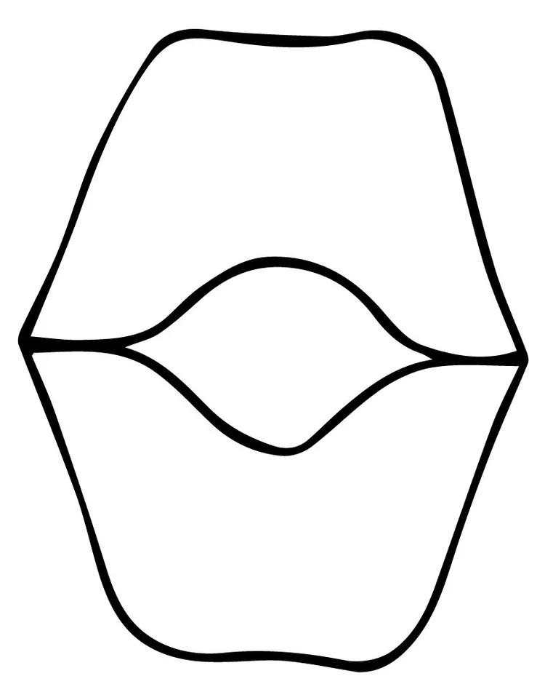
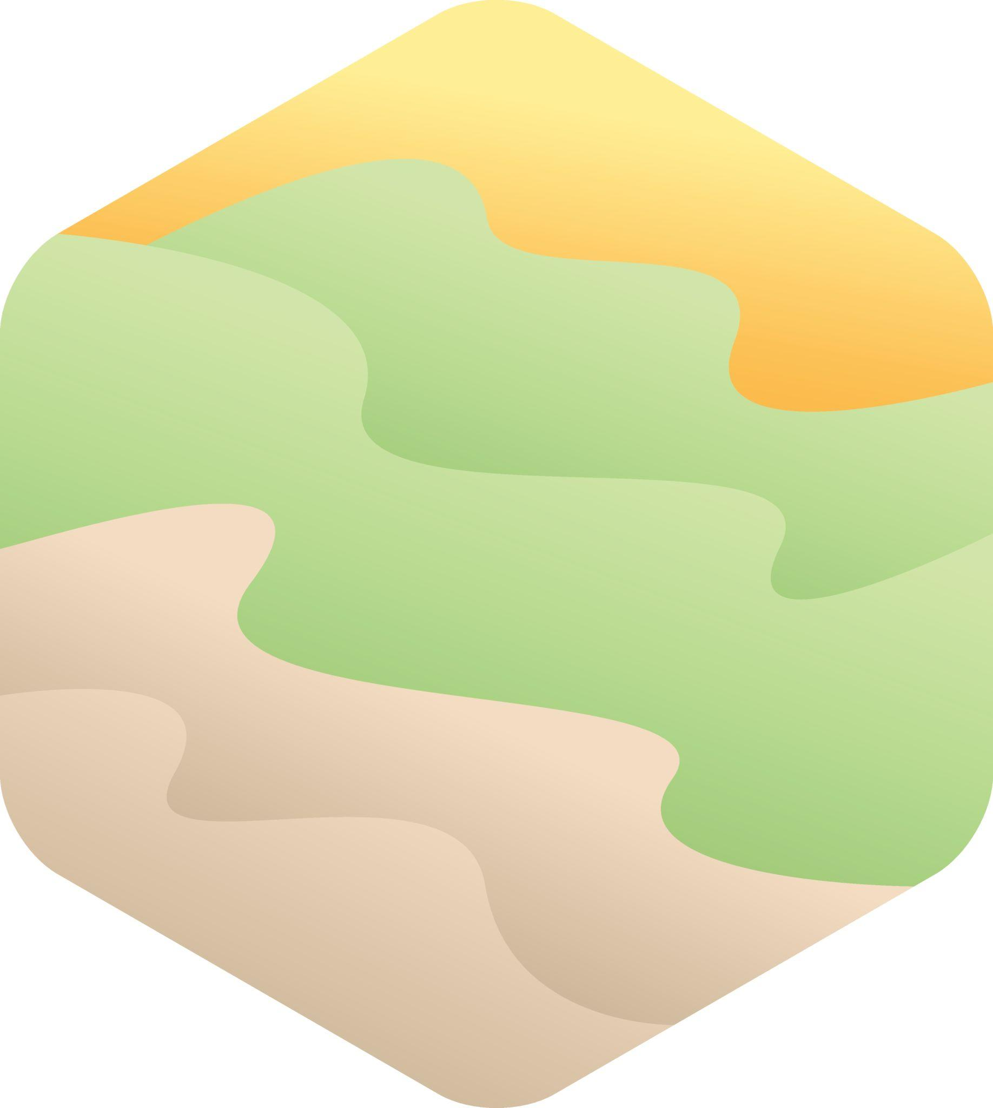
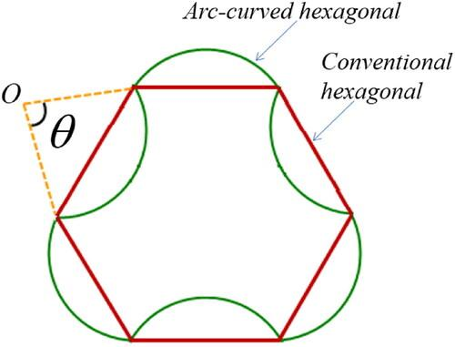
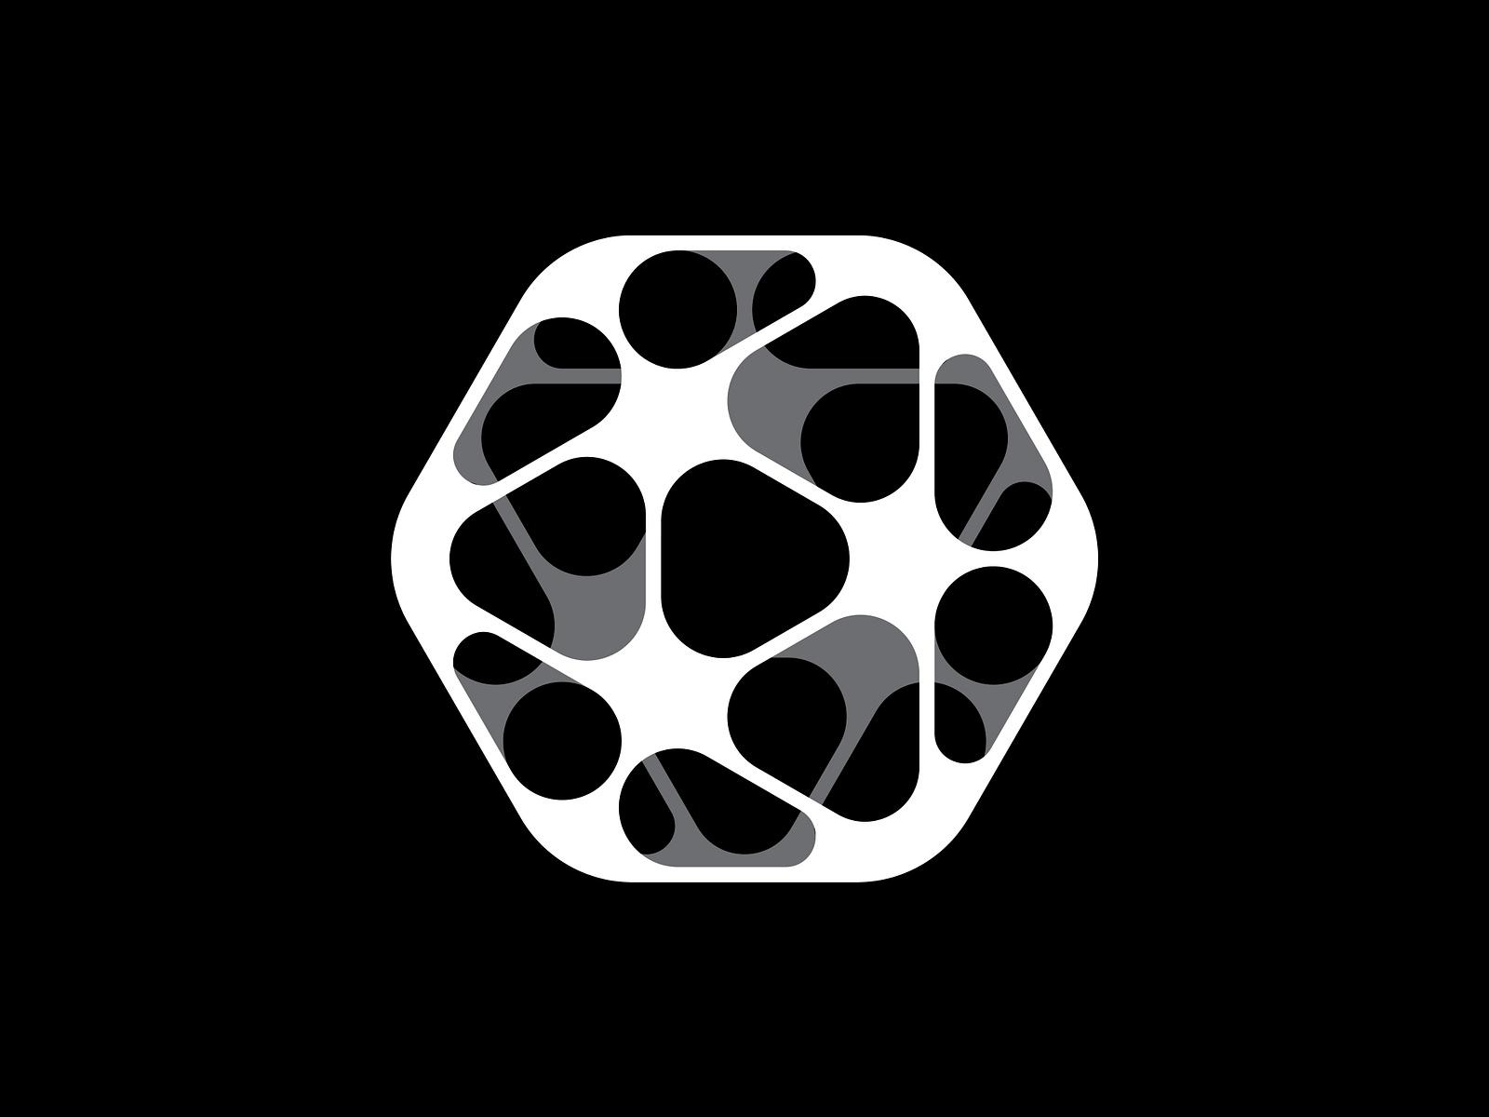

5. Polygon–Leaf-Like Closed Shape
# Source: AI Source: Provided by: [Data Path: Persons Table -> ID Column: 1, Name_En Column: Motasem Essam] -> From: [ChatGPT] on [7/25/2026]
A polygonal portion combined with a smooth curve resembling a leaf.
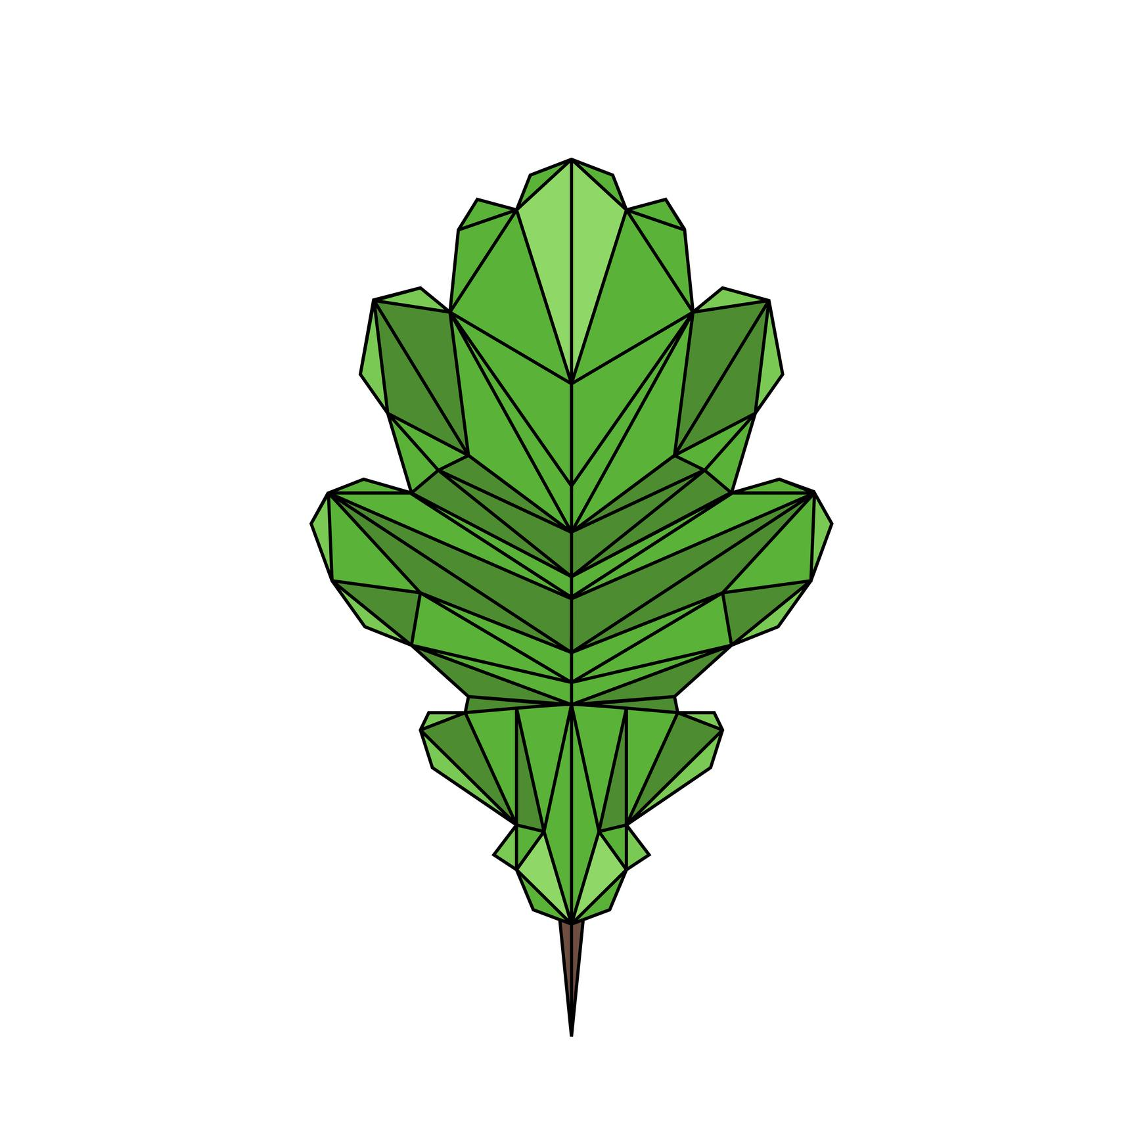


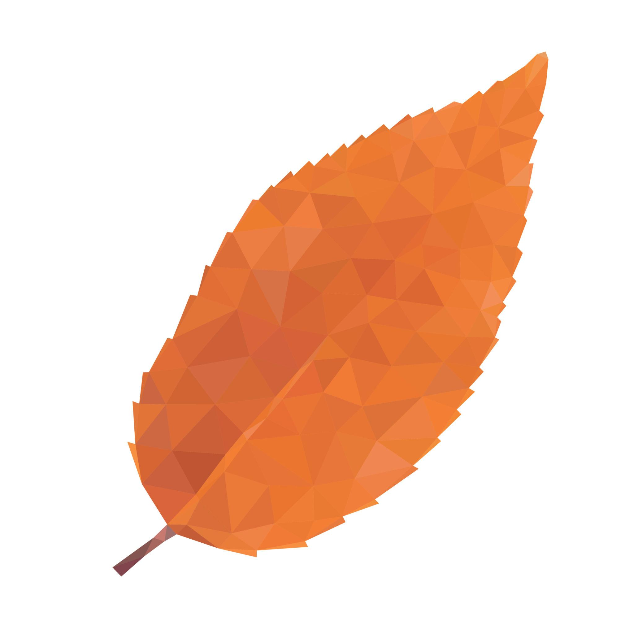
This is particularly useful when distinguishing geometric structure from organic appearance.

6. Polygon–Lobed Organic Closed Shape
# Source: AI Source: Provided by: [Data Path: Persons Table -> ID Column: 1, Name_En Column: Motasem Essam] -> From: [ChatGPT] on [7/25/2026]
A polygonal section combined with one or more rounded organic lobes.
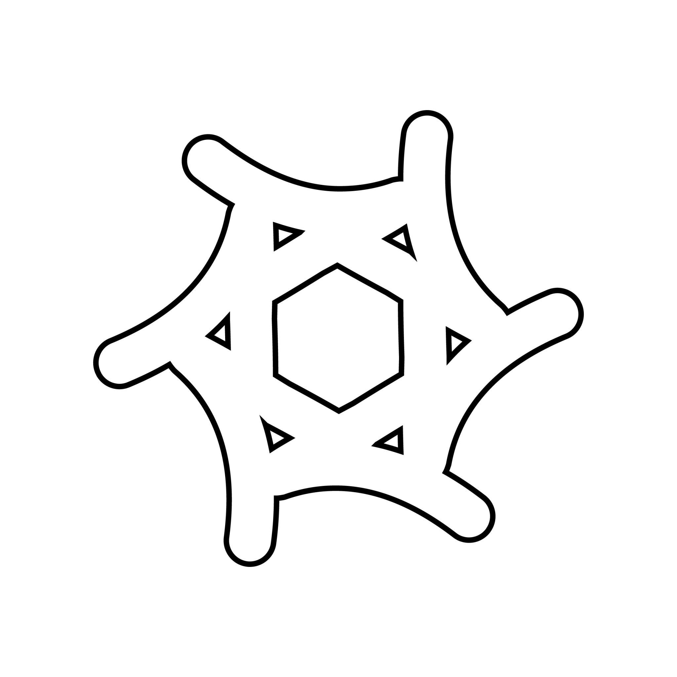
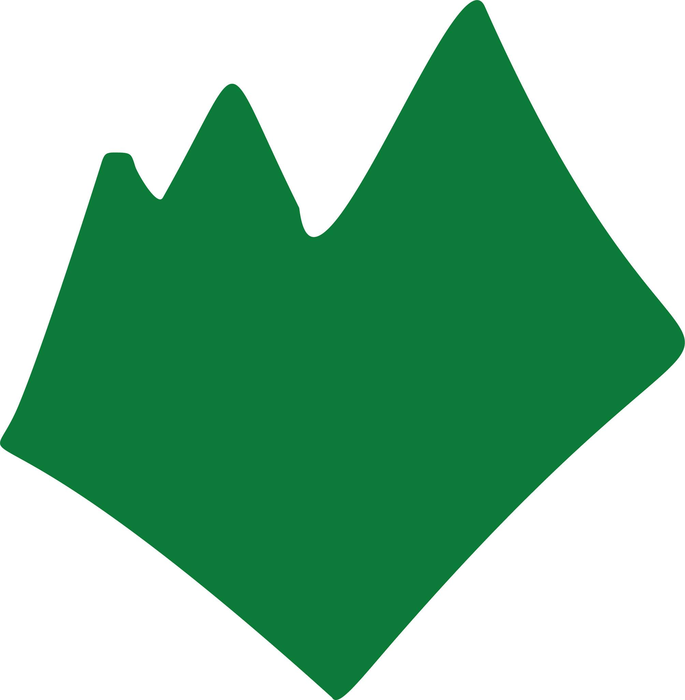
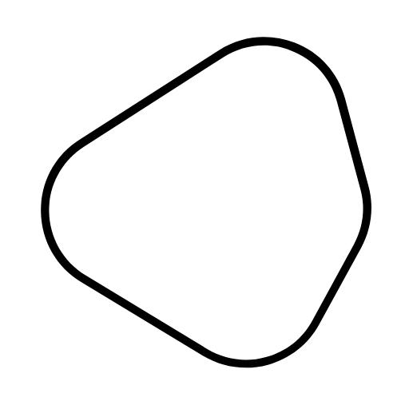
The lobes do not need to have identical sizes or curvature.

7. Polygon–Freeform Organic Closed Shape
# Source: AI Source: Provided by: [Data Path: Persons Table -> ID Column: 1, Name_En Column: Motasem Essam] -> From: [ChatGPT] on [7/25/2026]
A polygonal section is combined with a freely designed organic-looking curve.
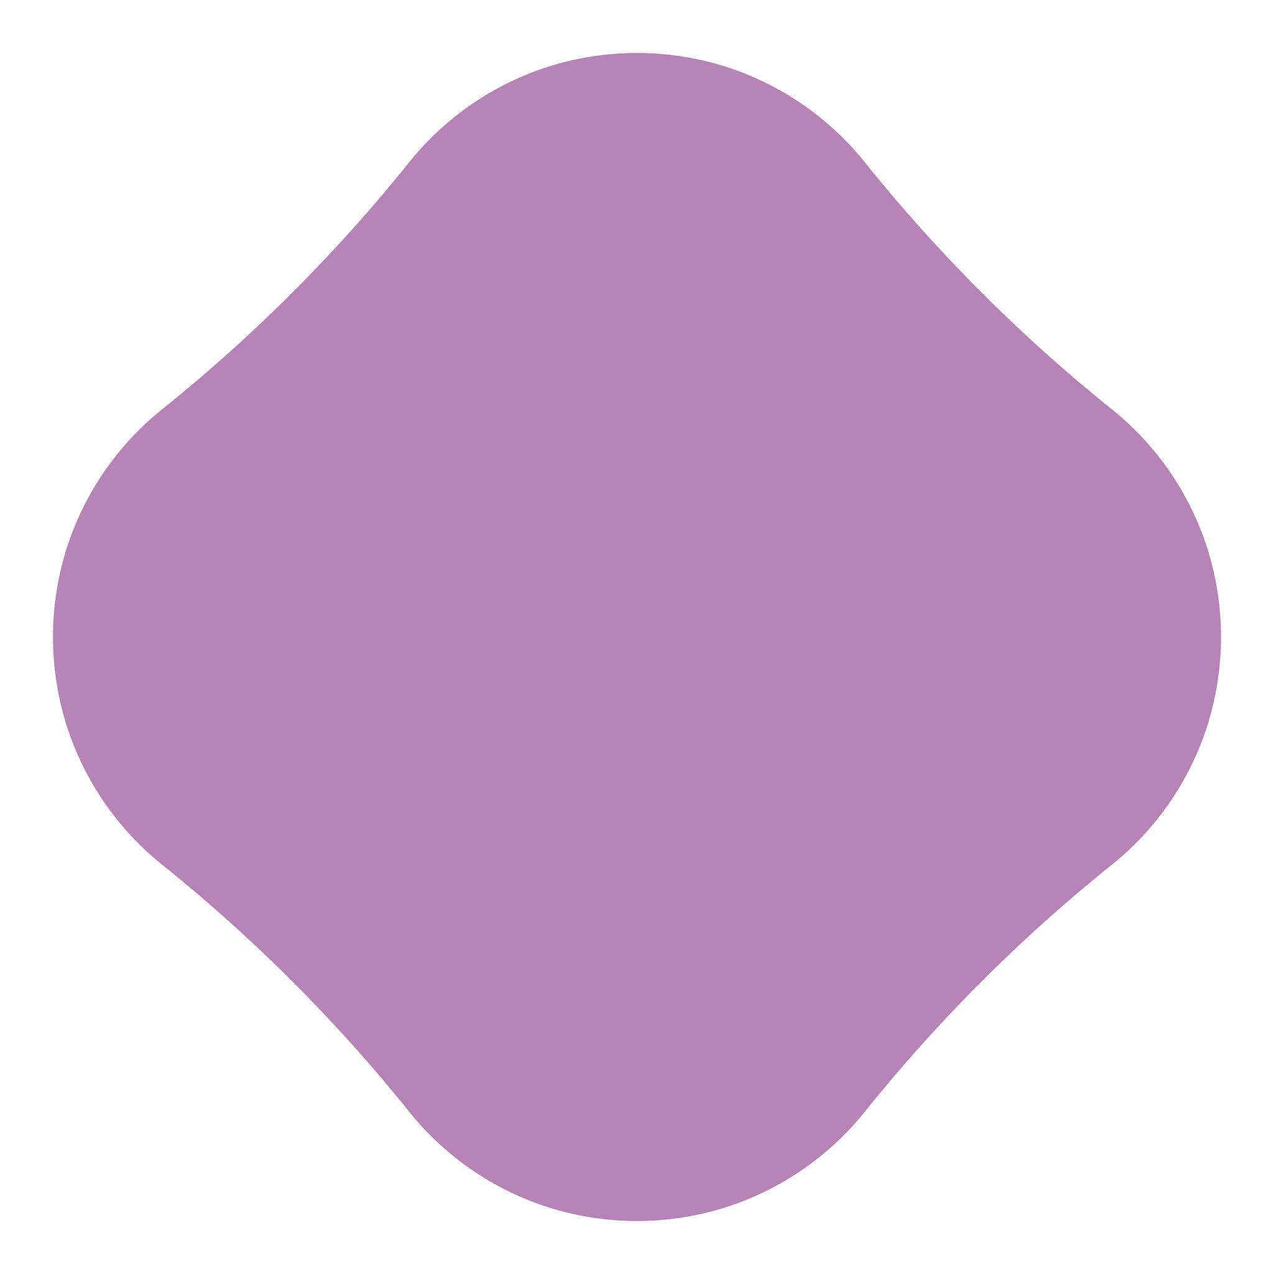
This type combines two distinct properties:
$$\boxed{\text{Polygonal Geometry}+\text{Freeform Organic Appearance}}$$

8. Polygon–Wavy Organic Closed Shape
# Source: AI Source: Provided by: [Data Path: Persons Table -> ID Column: 1, Name_En Column: Motasem Essam] -> From: [ChatGPT] on [7/25/2026]
A polygonal component is combined with an irregular, wavy organic boundary.
The curved portion may contain:
- Unequal waves.
- Different amplitudes.
- Variable curvature.
- Unequal spacing.

9. Polygon–Natural Object Closed Shape
# Source: AI Source: Provided by: [Data Path: Persons Table -> ID Column: 1, Name_En Column: Motasem Essam] -> From: [ChatGPT] on [7/25/2026]
A polygonal component is combined with a curved portion resembling a naturally occurring object.
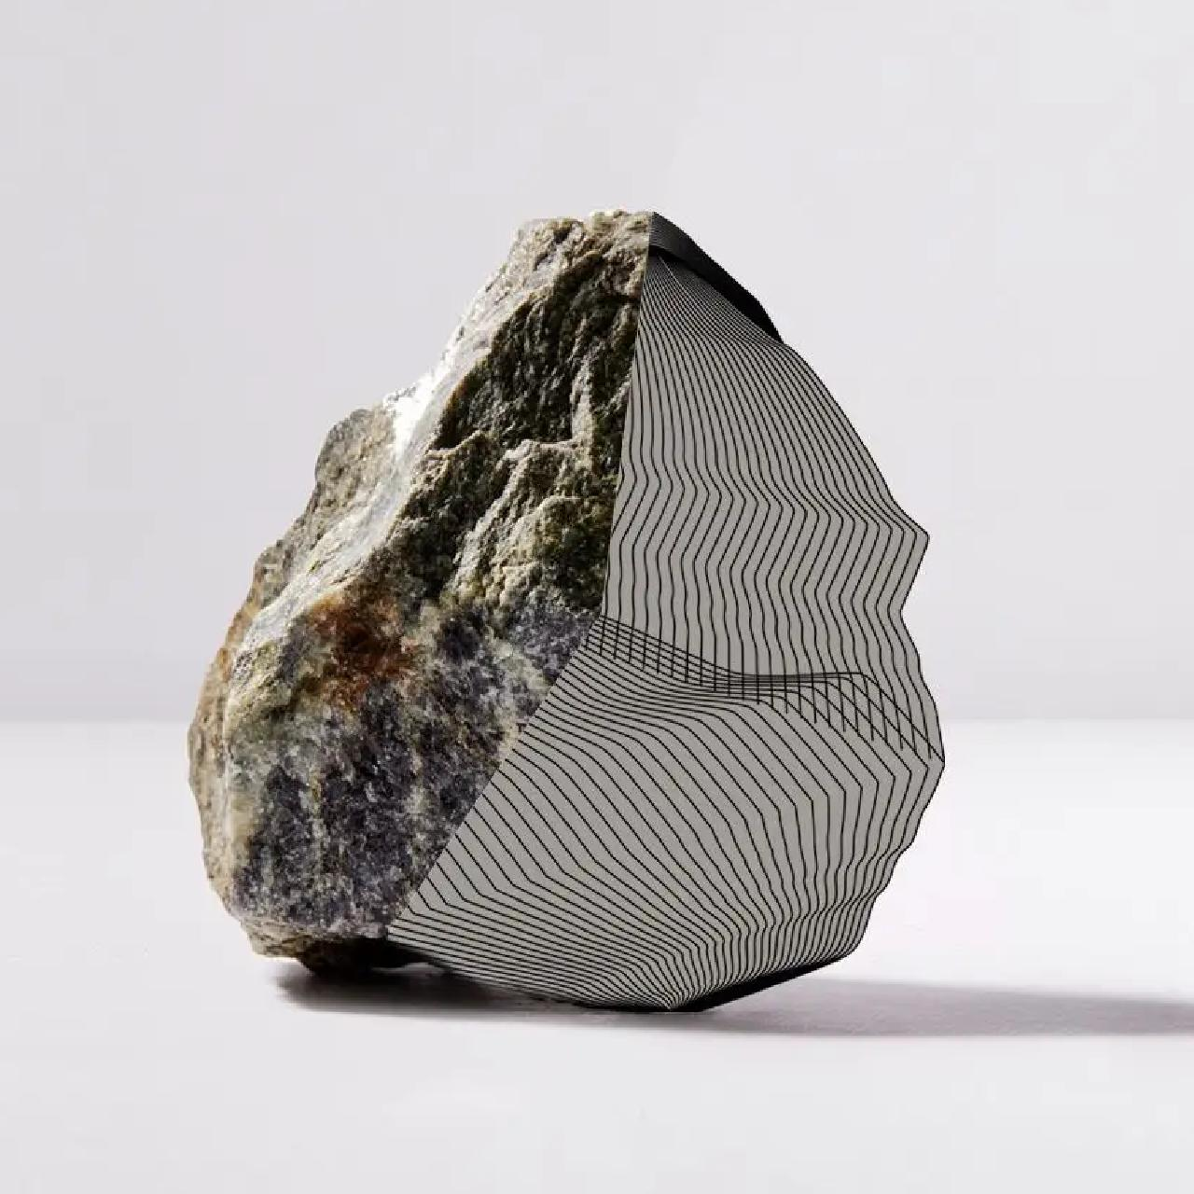
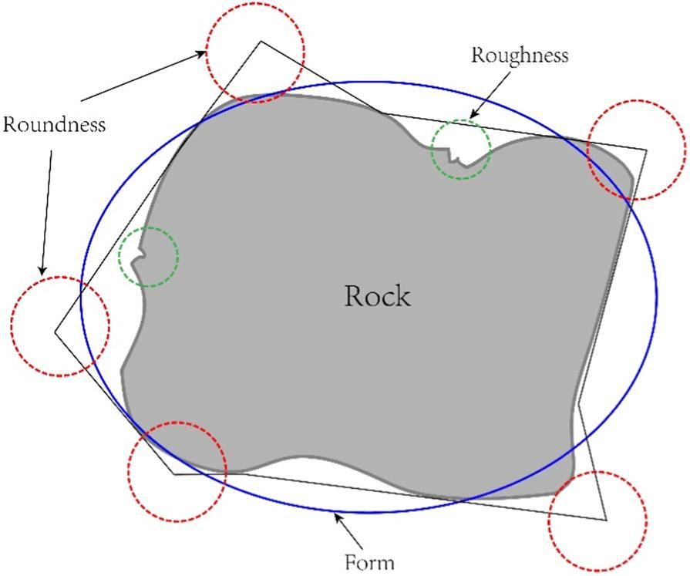
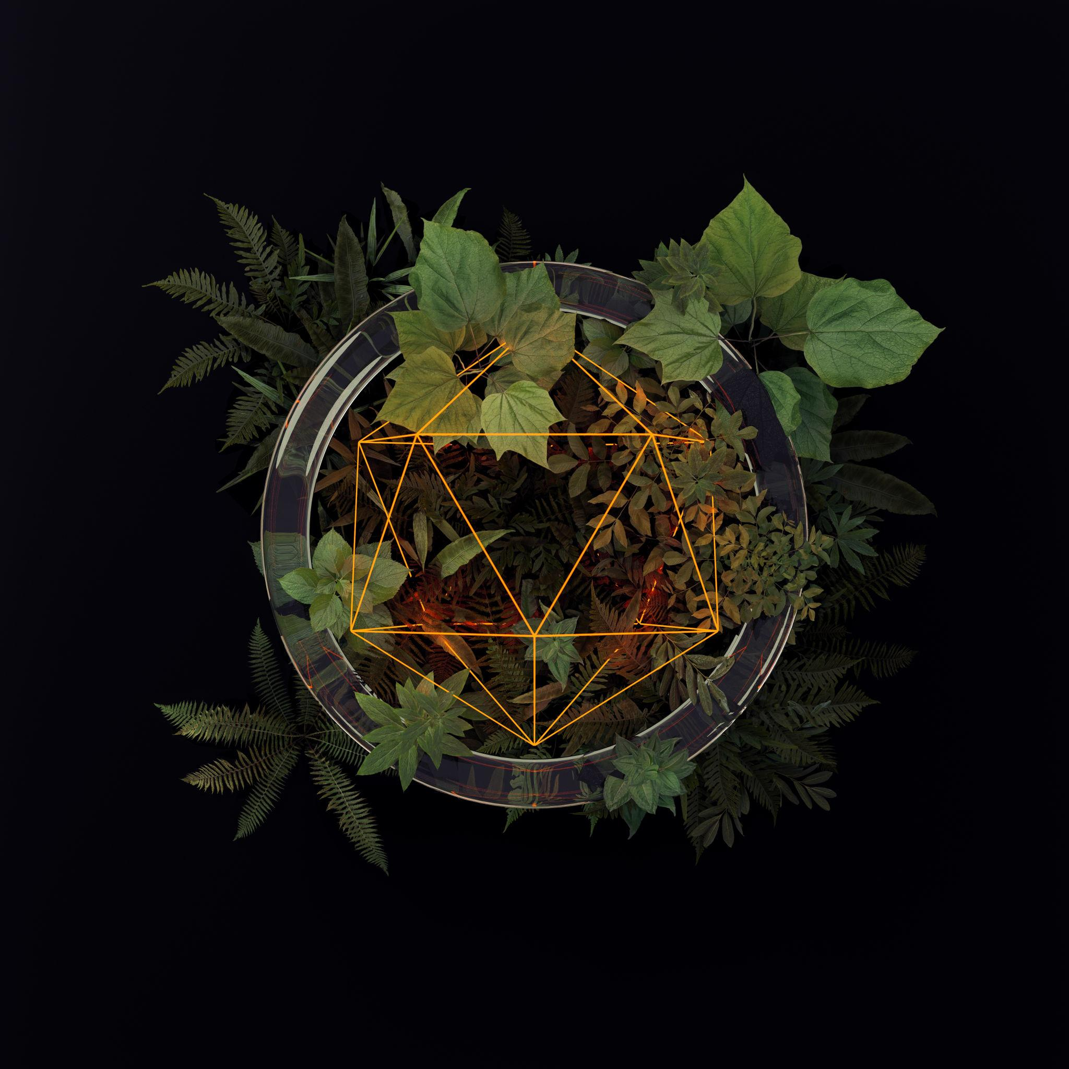
Examples may resemble:
- Rocks.
- Leaves.
- Seeds.
- Shells.
- Natural objects.

10. Irregular Polygon–Organic Closed Shape
# Source: AI Source: Provided by: [Data Path: Persons Table -> ID Column: 1, Name_En Column: Motasem Essam] -> From: [ChatGPT] on [7/25/2026]
An irregular polygon is combined with one or more irregular organic curves.
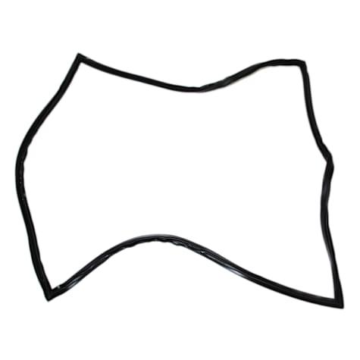
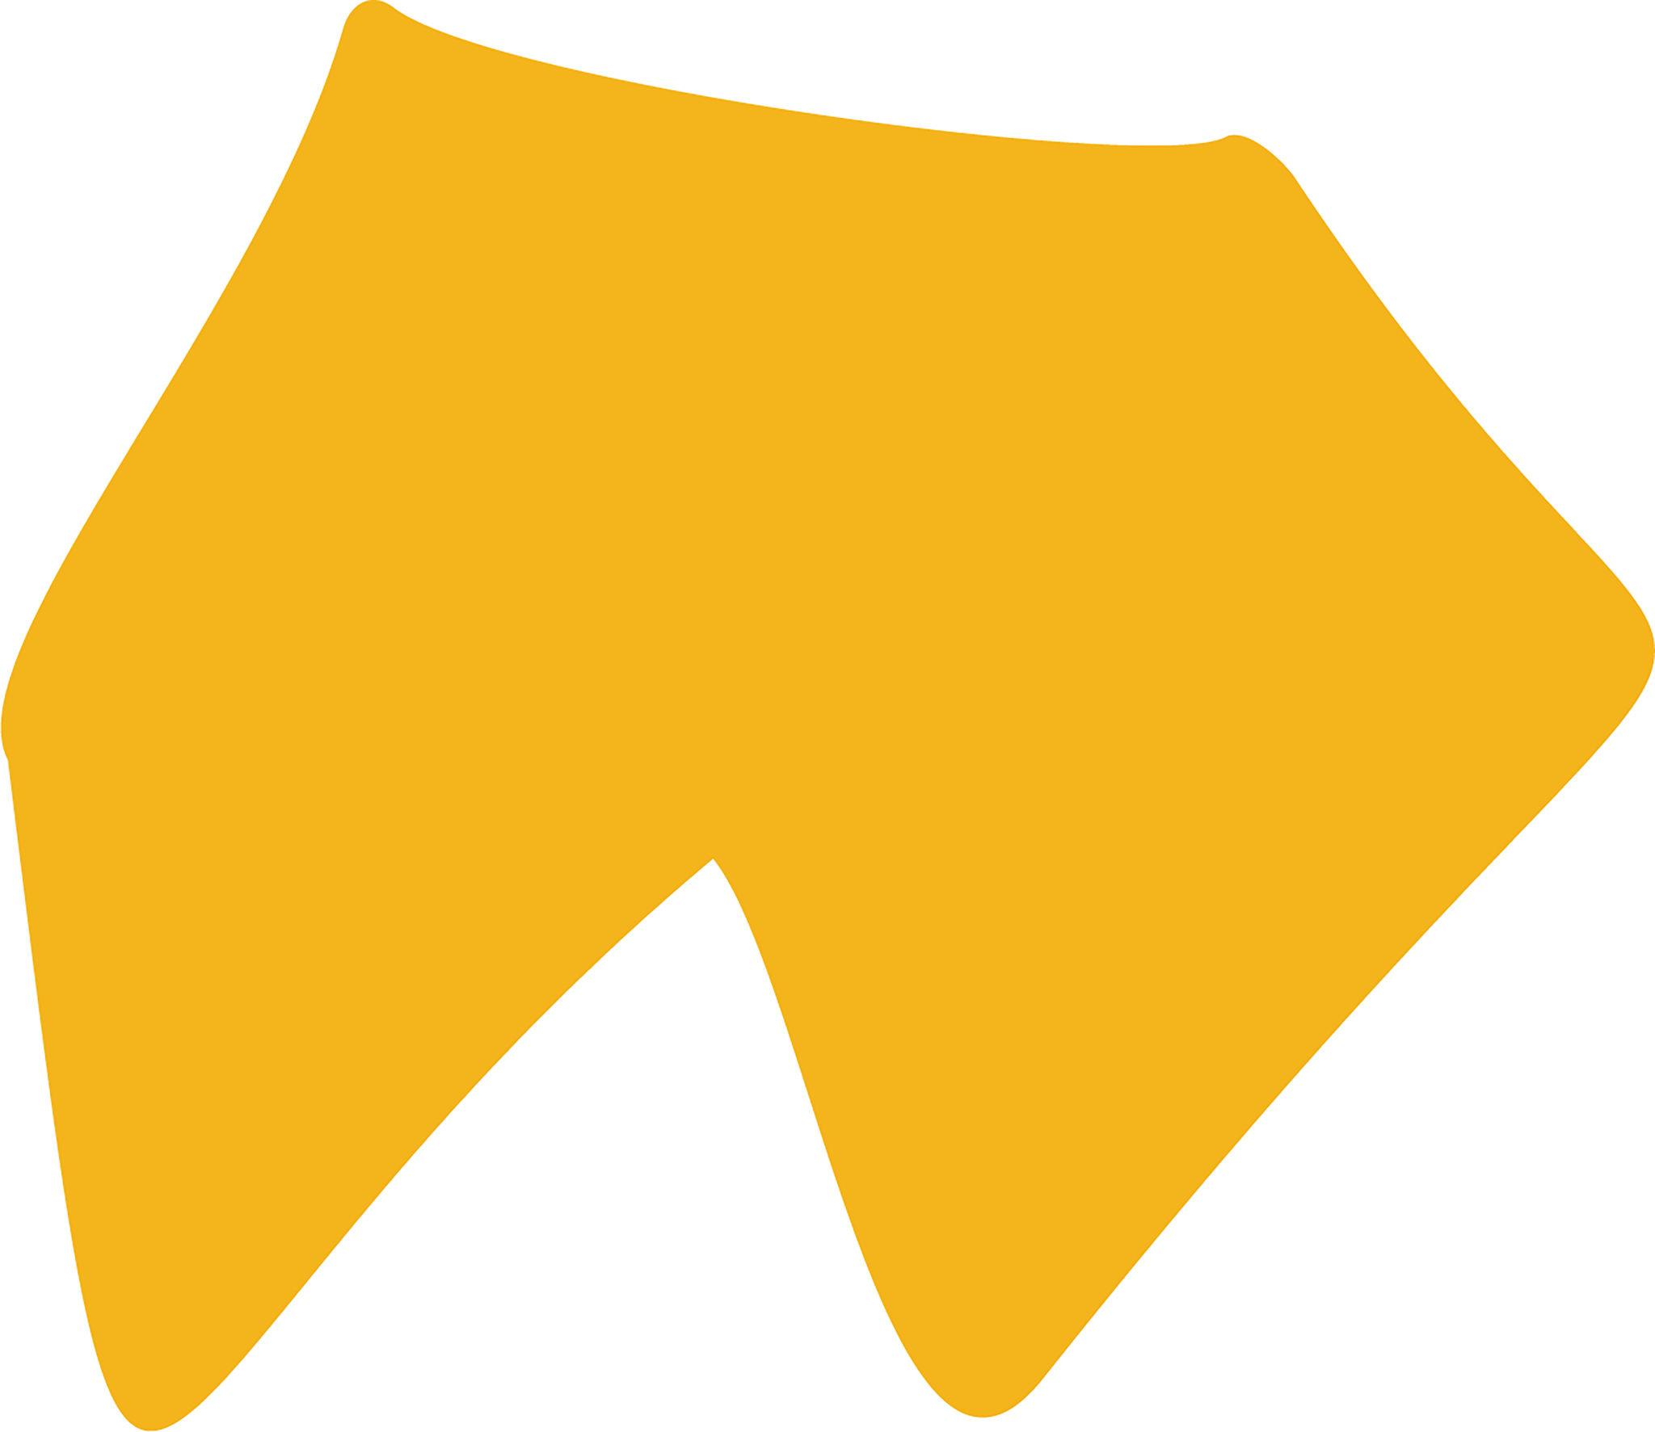
This is the most general form of the category.
It may have:
- Unequal straight segments.
- Unequal angles.
- Variable curved portions.
- No axis of symmetry.
- Irregular overall appearance.

Polygon–Organic vs. Polygon–Circular
# Source: AI Source: Provided by: [Data Path: Persons Table -> ID Column: 1, Name_En Column: Motasem Essam] -> From: [ChatGPT] on [7/25/2026]
This distinction is important in your classification system.
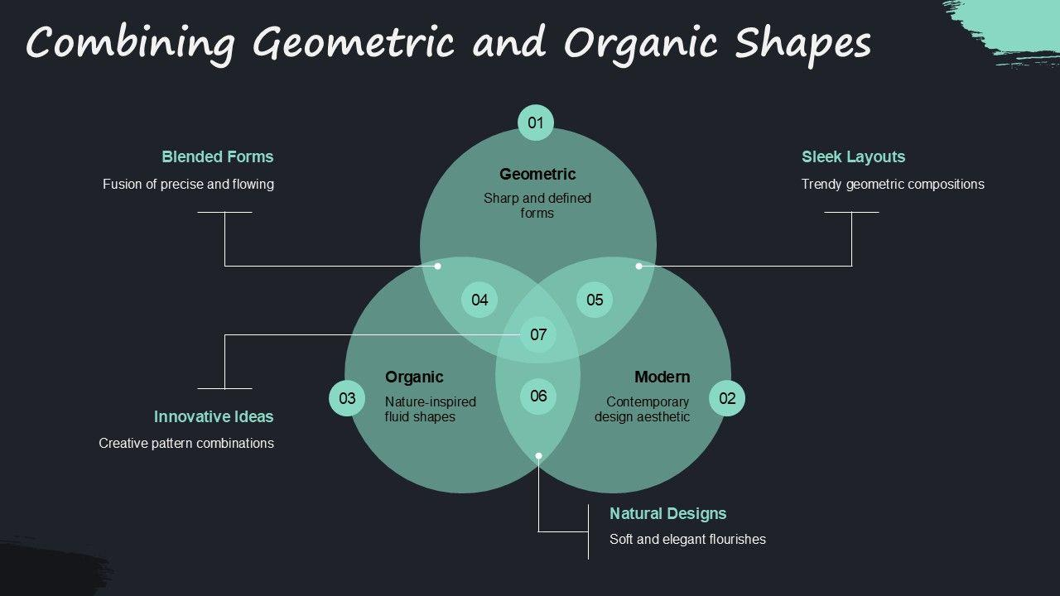
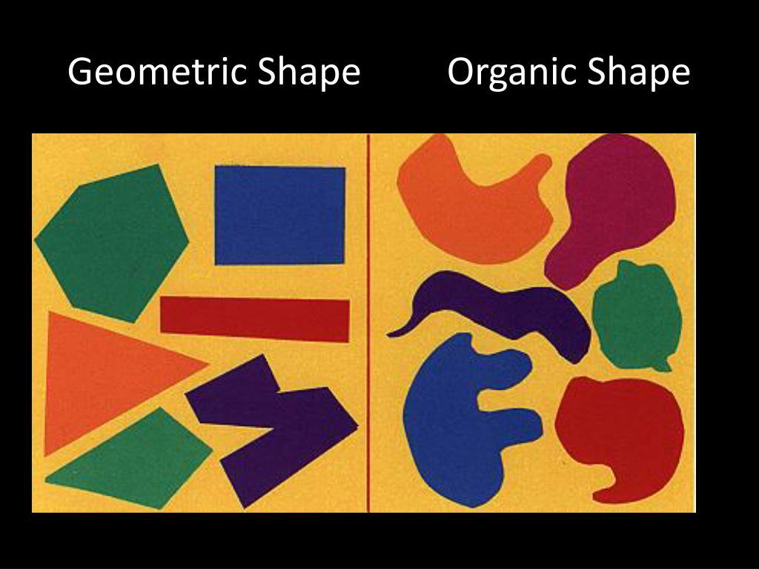
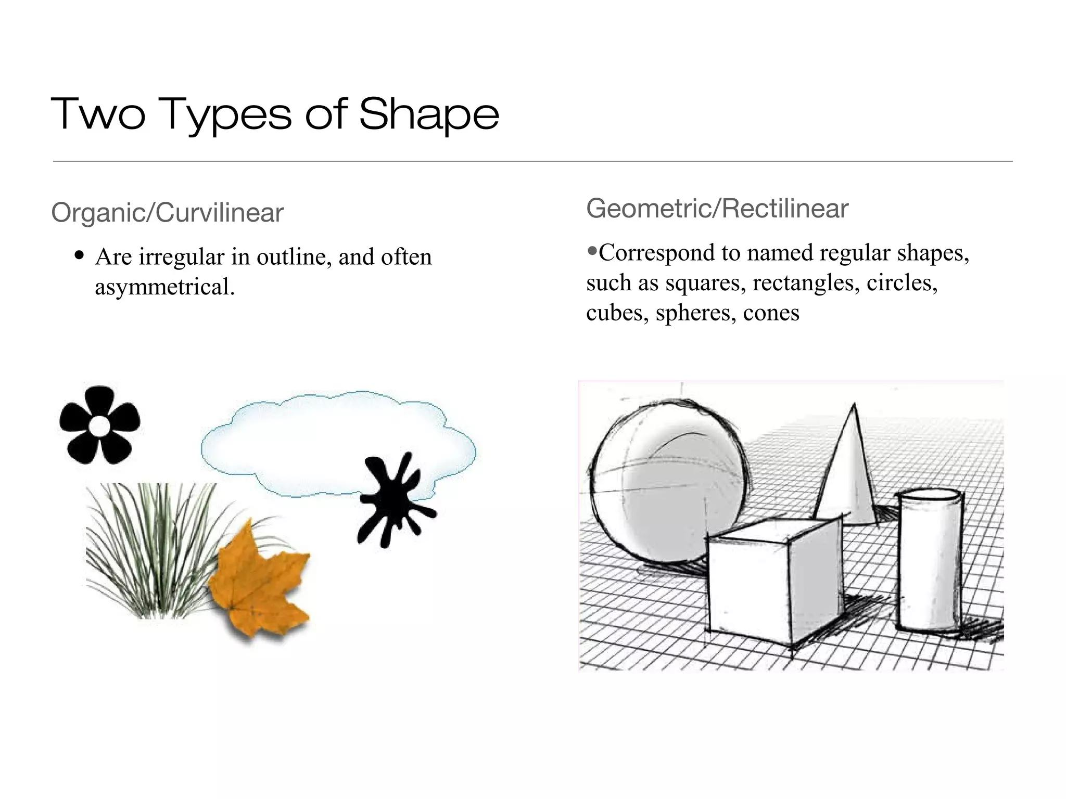
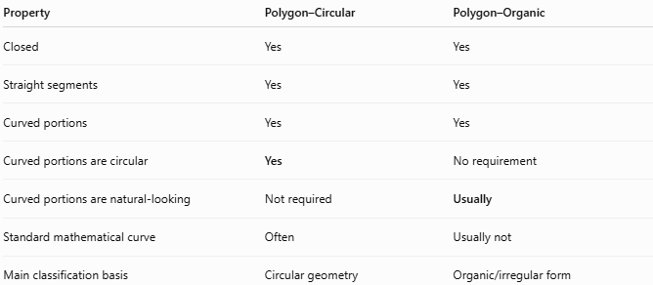
Property | Polygon–Circular | Polygon–Organic
Closed | Yes | Yes
Straight segments | Yes | Yes
Curved portions | Yes | Yes
Curved portions are circular | Yes | No requirement
Curved portions are natural-looking | Not required | Usually
Standard mathematical curve | Often | Usually not
Main classification basis | Circular geometry | Organic/irregular form
For example:
$$\boxed{\text{Polygon + Circular Arc}→\text{Polygon–Circular}}$$
while:
$$\boxed{\text{Polygon + Natural Irregular Curve}→\text{Polygon–Organic}}$$

Polygon–Organic vs. Polygonal Shapes
# Source: AI Source: Provided by: [Data Path: Persons Table -> ID Column: 1, Name_En Column: Motasem Essam] -> From: [ChatGPT] on [7/25/2026]
A pure polygon has only straight-line sides.
A polygon–organic mixed shape contains both straight and curved portions.
$$\boxed{\text{Polygonal Shape}=\text{Straight Segments Only}} \\ \boxed{\text{Polygon–Organic Shape}=\text{Straight Segments}+\text{Organic Curves}}$$

Area
# Source: AI Source: Provided by: [Data Path: Persons Table -> ID Column: 1, Name_En Column: Motasem Essam] -> From: [ChatGPT] on [7/25/2026]
A Polygon–Organic Closed Shape is a composite area.
Its area can be determined by decomposing the shape into simpler components:
$$\boxed{A_{\text{total}}=A_{\text{polygon}}±A_{\text{organic curved region}}}$$
For a general organic curve, there is no universal simple area formula. Numerical methods, integration, or coordinate-based measurement may be required.

Perimeter
# Source: AI Source: Provided by: [Data Path: Persons Table -> ID Column: 1, Name_En Column: Motasem Essam] -> From: [ChatGPT] on [7/25/2026]
Its perimeter contains both straight and curved portions:
$$\boxed{P=L_{\text{polygonal}}+L_{\text{organic curve}}}$$
The straight portion is found by ordinary segment lengths, while the curved portion is found using arc-length methods or numerical measurement.

Key Points
# Source: AI Source: Provided by: [Data Path: Persons Table -> ID Column: 1, Name_En Column: Motasem Essam] -> From: [ChatGPT] on [7/25/2026]
A Polygon–Organic Closed Shape is:
$$\boxed{\text{Closed}+\text{Polygonal Segments}+\text{Organic Curved Portions}}$$
It:
- Has a completely closed boundary.
- Contains at least one polygonal straight portion.
- Contains at least one organic-looking curved portion.
- Encloses a bounded region.
- Does not require the curved portion to be circular.
- May be regular or irregular.
- May be symmetric or asymmetric.
- Can resemble natural or biological forms.

Conclusion
# Source: AI Source: Provided by: [Data Path: Persons Table -> ID Column: 1, Name_En Column: Motasem Essam] -> From: [ChatGPT] on [7/25/2026]
Polygon–Organic Closed Shapes are composite closed shapes that combine straight polygonal boundaries with irregular, smooth, organic-looking curves. They include triangle–organic, quadrilateral–organic, pentagon–organic, hexagon–organic, leaf-like, lobed, freeform organic, wavy organic, natural-object, and irregular polygon–organic forms. The key distinction from Polygon–Circular Closed Shapes is that the curved portion is organic and non-standard rather than specifically circular.

